Multiple-choice section

Question 1 [2.1]

Which of the following are multiples of 10?

A 11, 12, 13, 14 B 10, 15, 20, 25 C 10, 20, 30, 40 D 2, 3, 5, 7, 11

Question 2 [2.2]

The first five prime numbers are:

A 2, 3, 5, 7, 11 B 0, 1, 3, 5, 9 C 1, 2, 3, 4, 5 D 1, 2, 3, 5, 7

Question 3 [2.4]

Which statement is correct?

A 6 < 5 B 2 < 9 C 10 > 12 D -6 < -10

Question 4 [2.5]

Calculate the following: 8 – 6 + 2

A -4 B 16 C -16 D 4

Question 5 [2.1]

50 is divisible by:

A 6 B 3 C 5 D 15

Question 6 [2.4]

Which set of numbers is in ascending order?

A 2, 4, 0, 2 B 9, 6, 3, 1 C -10, 8, 10, -5 D 3, 5, 7, 9

Question 7 [2.6]

Calculate: 7 – (-3)

A 10 B 4 C -4 D -10

Question 8 [2.7]

-15 – (-1) – (+1) simplifies to:

A -15 – 1 – 1 B -15 + 1 + 1 C -15 + 1 – 1 D 15 – 1 + 1

Question 9 [2.3]

The number 24 expressed as a product of its prime factors is:

A 2 × 2 × 3 B 2 × 2 × 2 × 3 C 1 × 22 D 2 × 12

Question 10 [2.2]

Which of the following is a composite number?

A 7 B 29 C 27 D 19

Question 11 [2.1]

The highest common factor (HCF) of 10 and 15 is:

A 5 B 10 C 15 D 30

Multiple-choice total marks: ____ / 11

Short answer section

Question 12 3 marks [2.1]

Complete the sentences about the divisibility tests.

(a) A number is divisible by 2 if the last digit is an __________ number.

(b) A number is divisible by 5 if the last digit is ______ or _______.

(c) A number is divisible by 3 if the sum of the digits is divisible by ______.

Question 13 3 marks [2.1]

Find the first five multiples of 4 and the first five multiples of 6. Circle the lowest common multiple (LCM) for 4 and 6.

|  |  |  |  |  |  |
| --- | --- | --- | --- | --- | --- |
|  | ___ × 4 | ___ × 4 | ___ × 4 | ___ × 4 | ___ × 4 |
| Multiples of 4 |  |  |  |  |  |

|  |  |  |  |  |  |
| --- | --- | --- | --- | --- | --- |
|  | ___ × 6 | ___ × 6 | ___ × 6 | ___ × 6 | ___ × 6 |
| Multiples of 6 |  |  |  |  |  |

Question 14 3 marks [2.1]

Find the highest common factor of 18 and 20, by first listing the factors of each number.

18: 1, 2, _________, ____________, __________, ________

20: 1, 2, _________, _________, _________

HCF: _____________

Question 15 2 marks [2.1]

Shade the numbers that are divisible by 2, 5 and 10.

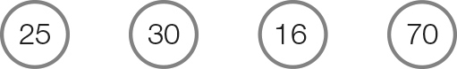

Question 16 1 mark [2.2]

Fill in the missing prime numbers.

2, _______, 5, _______, 11.

Question 17 3 marks [2.2]

Explain why 9 and 15 are not co-prime. List all factors of 9 and 15 to help you explain your answer.

Question 18 2 marks [2.2]

Write the smallest composite number that is greater than each of these numbers.

47: _____

22: _____

18: _____

1: _____

Question 19 2 marks [2.3]

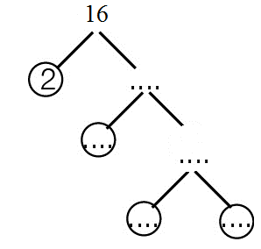Complete the factor tree for the number 16 and then express 16 as a product of its prime factors in index form.

16 = 2 × ____ × ____

16 = 2 × ____

Question 20 2 marks [2.3]

What number is the product of these prime factors?

32 × 22

= ________ × _________ × _________ × _________

= _________ × _________

= _________

Question 21 2 marks [2.4]

Write an integer that represents each of the following values.

(a) 10 m above the ground

(b) 6 °C below zero

Question 22 3 marks [2.4]

Use the symbols > or < to compare each pair of integers.

(a) 12 __________ -8

(b) -6 __________ -2

(c) 0 __________ -1

Question 23 2 marks [2.4]

Arrange the following integers in ascending order.

-3, 15, 0, 5, -1, 1

______, _______, ______, _______, ______, ______.

Question 24 2 marks [2.4]

Arrange the following integers in descending order.

-10, -20, -5, 20, -15, 5

______, _______, ______, _______, ______, ______.

Question 25 3 marks [2.4]

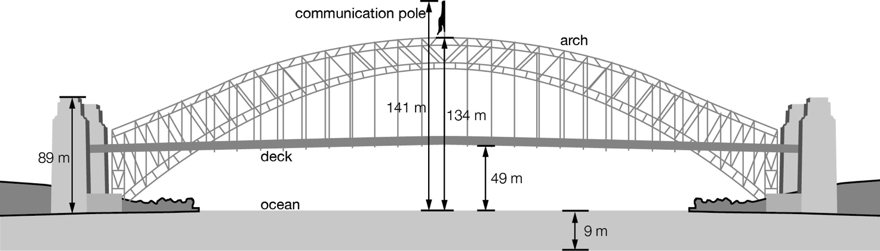

(a) What is the distance from the top of the arch to the bottom of the ocean?

(b) What is the distance from the top of the communications pole to the bottom of the deck?

Question 26 2 marks [2.7]

Simplify the following equation.

12 – (-2) + -1 + 4

Question 27 3 marks [2.6]

Fill in the blank with the correct integer and a positive or negative sign to complete the equation.

(a) ______ + 13 = 22

(b) -3 + ______ = 20

(c) ______ – 14 = 10

Question 28 4 marks [2.5]

Use the number lines to calculate the following.

(a) -3 + 4 + 1

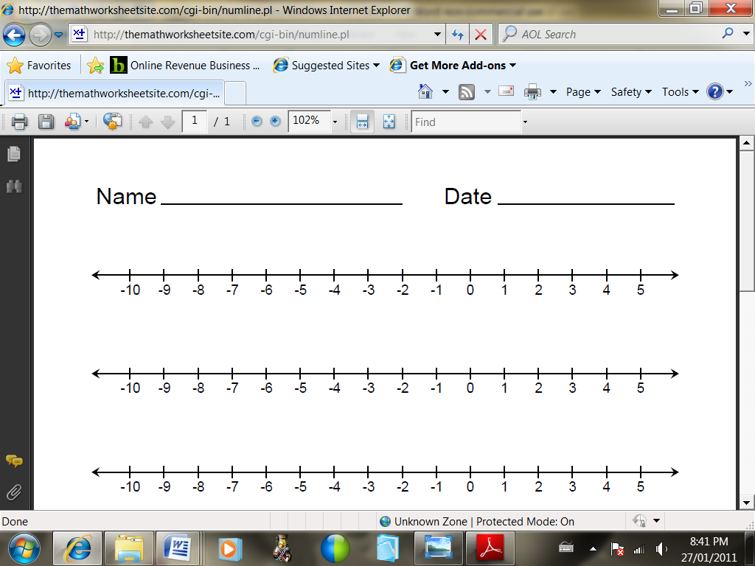

(b) 18 – 15 – 9

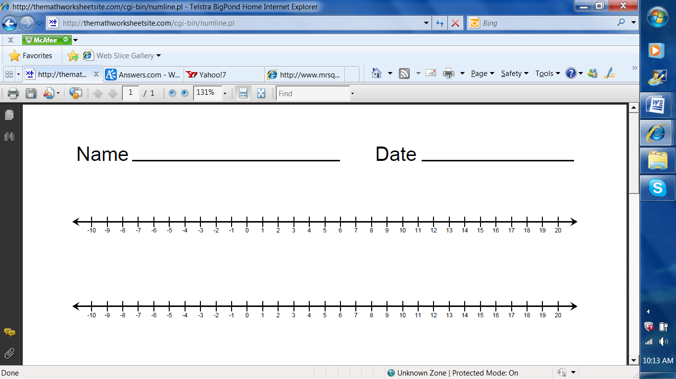

Question 29 2 marks [2.6]

Translate the following sentence into an equation using positive and negative integers.

(a) Jon took 3 steps backwards, four steps forward, then one steps backwards.

(b) Where did Jon end-up?

Question 30 2 marks [2.7]

Write true or false for the following.

(a) 20 – (-5) = 20 + 5 ____________________

(b) 35 + (-10) = 35 + 10 ____________________

Question 31 2 marks [2.7]

Rewrite the following in a simpler form.

(a) -(-5) (b) + (-11) (c) - (+9) (d) + (+32)

Question 32 2 marks [2.6]

Use a number line to calculate 4 – 12 + 6.



Question 33 2 marks [2.6]

Consider the following four cards.

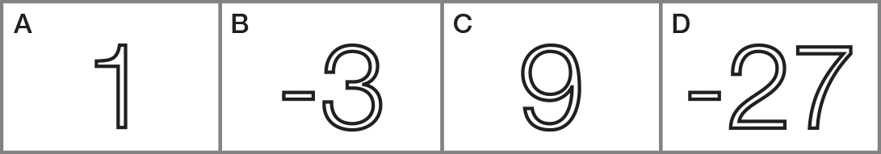

Which of the above cards is needed to make the following number sentence true?



Short answer total:_________/52

Extended answer section

Question 34 5 marks [2.7]

The following table shows the average daily temperature (°C) recorded at the South Pole.

|  |  |  |  |  |  |  |  |  |  |  |  |
| --- | --- | --- | --- | --- | --- | --- | --- | --- | --- | --- | --- |
| Jan | Feb | Mar | Apr | May | Jun | July | Aug | Sept | Oct | Nov | Dec |
| -29 | -41 | -54 | -57 | -57 | -58 | -60 | -61 | -60 | -51 | -39 | -28 |

(a) What is the average daily temperature for November? _________

(b) Which month is the coldest? ___________________________________________

(c) Which month is the warmest? __________________________________________

(d) What is the difference in temperature between the warmest and the coldest months?

Extended answer total:_________/5

TOTAL test marks: _______ / 68